Spring Creek Watershed Commission Phase 2 Report
Collaborative Framework for Developing a One Water Plan and Leadership
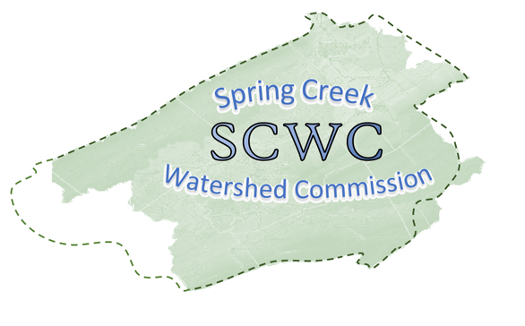
The vision for the Spring Creek Watershed is an integrated management of water resources in an environmentally, economically, and socially beneficial manner. This will foster a vibrant, prosperous watershed where natural and human communities thrive, and citizens embrace the value of the watershed’s assets and sustain its resources for current and future generations.
Last Updated: 11-13-19
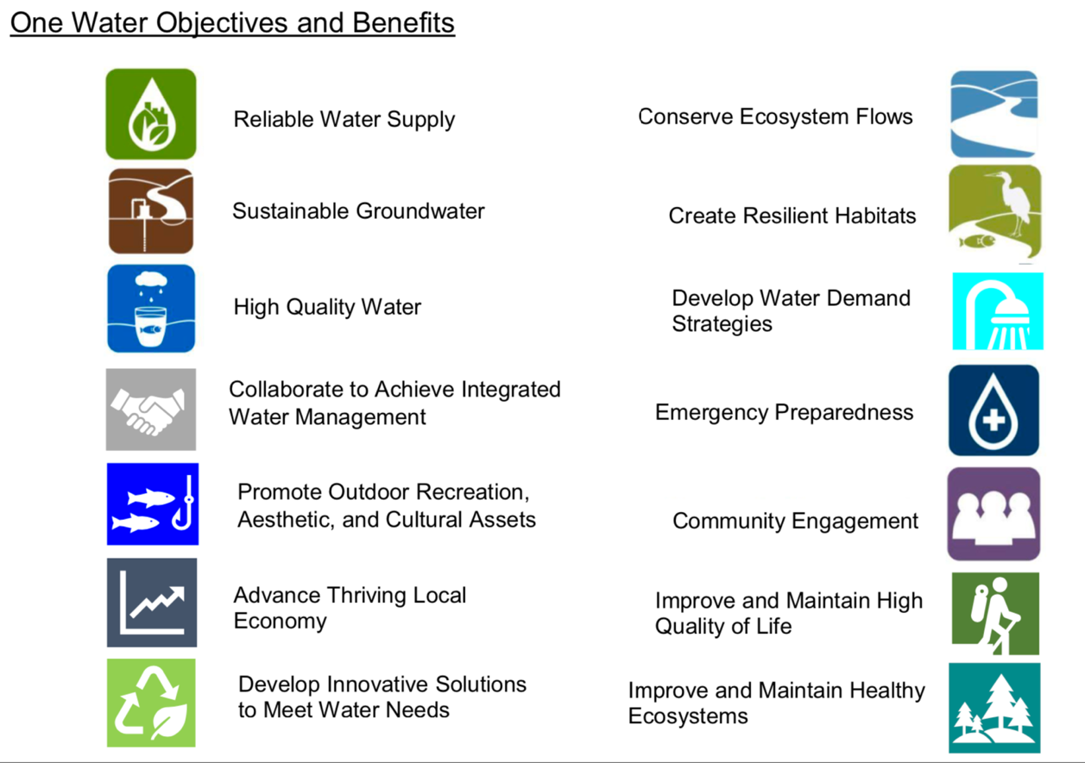

Table of Contents

Introduction
One Water Vision
Resiliency
Community Stakeholder Involvement
Why aren’t mandatory, enforceable standards a priority of a One Water Plan?
A Planning Framework
Who Pays for the implementation of the Phase III Plan?
Who is involved?
What will be included in the Phase III Plan?

Phase 2 Report
Description of the watershed
Spring Creek Watershed Plan Phase 1
Actions Following the Phase 1 Plan
Current Watershed Challenges
Management Challenges
Major Stakeholders
Transitioning to A One Water Approach for Integrated Management
Spring Creek Watershed Planning Phase 2
Approach to a Phase 3 One Water Plan
Spring Creek Watershed Commission One Water Plan Mission Statement
Spring Creek Watershed Commission One Water Plan Value Statements
Spring Creek Watershed One Water Plan Guiding Principles
Framework for Spring Creek One Water Plan
Goals, Objectives, Metrics and Desired Outcomes
Phase 3 One Water Plan Development
Administrative Capacity

Introduction
The Spring Creek Watershed Commission (SCWC) was formed in 1996 to bring representatives of municipalities together to discuss common issues. The mission statement of the SCWC is to provide a vision, leadership and develop a plan to protect and enhance the quality of life in the watershed.
In 2003 Phase 1 of the Spring Creek Watershed Management Plan entitled “Our Challenges and a Direction for the Future” was completed and primarily focused on environmental challenges and solutions (https://www.springcreekwatershedcommission.org/phase-i-report-information).
In 2017, a core group of the Spring Creek Watershed Commission formed to continue the watershed planning process. An AmeriCorps staff person had been hired to provide administrative support. SCWC chair Denny Hameister secured $16,250 in contributions from stakeholders that included government, non-profits, Penn State and local business interest.
This Phase 2 report was developed through a series of public meetings and meetings of a technical work group. This report represents a compilation of ideas gathered and organized during these meetings. It is not a plan in itself but rather a framework of ideas to guide development of the Spring Creek Watershed Plan.

ONE WATER VISION
A general consensus was achieved during the Phase 2 process for an integral, or “One-Water,” planning process. In short, collaboration between local, state, and federal agencies creates opportunities for dialogue about water management goals and activities and coordinates the work of various interested parties. It does not regulate their work. A One Water Plan is not an effort to change local governance but to integrate management and leadership.
The One Water Plan goals for the Spring Creek Watershed focus on advancing the local economy, enhancing community vitality, and improving the cold-water ecosystem including the top wild trout fishery in Pennsylvania. The plan will facilitate managing water resources holistically and sustainably to benefit people and the environment in a way that is informed by community values. The One Water approach results in lower long-term costs across the watershed for its water-related infrastructure.
Currently there is no holistic plan to identify and prioritize water resource challenges, opportunities, and solutions to ensure water is available to meet future community and ecosystem needs. Holistic planning allows opportunities for solutions that cross traditional boundaries between water supply, stormwater and wastewater, as well as municipal boundaries and service area boundaries. A comprehensive plan provides information to municipalities and Centre County to help inform land use decisions and water resource investments.
Until recently, watershed planning has often been an attempt to reduce the impacts of growth and development on the environment. It is viewed as a zero-sum game, where the environment is slowly degraded to allow for more human activity. Most Federal, State, and Local regulations are reactive and assume that it is a zero-sum game. That assumption is incorrect. The One Water approach provides a more beneficial and proactive approach to water management. Significant investment is made to water-related projects to increase the environmental resiliency so that as growth happens, the watershed gets healthier. The growth produces enough funding to pay for the projects.

Resiliency
Resiliency is the backbone of a One Water Plan. Resiliency is the ability to respond favorably to change and to recover quickly from adversity. Every ecosystem is subject to changes in climate over time as well as heavy storms and droughts. A One Water Plan manages water resources for long-term resilience and reliability to meet both community and ecosystem needs. A One Water Plan will support growth and development desired by individual municipalities by ensuring both quantity and quality of our water under all conditions.

Community and Stakeholder Involvement
The One Water approach relies heavily on partnerships and recognizes that progress will only be made when all stakeholders have a seat at the table. A diverse workgroup was established to draft guiding principles, goals, objectives, and metrics for outcome-based solutions. Local municipalities, water utilities, business and industry, state and federal agencies, nonprofits, and the community have and will continue to be involved with each step of the One Water Plan. Opportunities for involvement include participation in work groups, task forces and committees, reviewing and commenting on plan components, and attending public input sessions.
Currently, each of those entities does what they believe is in the best interest of their served communities. During the development of the Phase III Plan, those individual interests are respected. There is always room for improvement. The proposed plan will identify potential innovative alternatives to the current method of service, and the entity can compare their current and future path with the other options. Decision makers will choose the alternative that most benefits their served community.

Why aren’t enforceable standards a priority of a One Water Plan?
Incentives are a key component of successful One Water Plans. Rather than passing ordinances to restrict property owners from taking actions on their property that might affect the watershed environment, the plan identifies ways to provide incentives that motivate more resilient approaches. For example, if the plan determines that parcels of land are vital to the drinking water supply, then the land could be conserved for this purpose. With a One Water Plan, it will be easier for each municipality, authority, business, and private citizen to decide to participate, without being mandated by regulations. A One Water Plan minimizes the need for mandatory, enforceable standards, which makes a One Water Plan easier to adopt.

A Planning Framework
What are benefits of a plan that benefit all municipalities and the environment? In addition to those on the cover page are the following:
  - A 50-year roadmap for integrated water resource planning in the Spring Creek Watershed.
  - One Water manages finite water resources for long-term resilience and reliability to meet both community and ecosystem needs.
  - One Water will identify where there is a connection between land use planning, stream stewardship, and water supply / wastewater functions.
  - The plan will provide a framework for measuring changes and improvements in watershed health through science-based metrics and targets.
  - Minimize public capital expenditures needed to correct flooding and water quality problems.
  - Further improve the high quality of life by promoting outdoor recreation that is supported by a healthy ecosystem and watershed including wild trout fishing, kayaking, and hiking.
Ultimately, the One Water Plan program encourages planners to look beyond individual water management projects – plans include programs that address education, recreation, soil health, monitoring, and more. The program also encourages local governments to move beyond jurisdictional boundaries to build regional partnerships and to seek out diverse funding sources.
As the planned projects are implemented, the watershed will increase in value. Not just dollars and cents but in terms of a healthier, more resilient watershed benefiting all people, including current and future generations.

Who Pays for the implementation of the Phase III Plan?
Typical costs for a One Water Plan are $300,000 to $500,000 for administrative support and consultants that specialize in water resource planning. An estimated $35,000 will be required to contract a project manager and administrative support to initiate the planning process. Participating entities will also assume costs for the time and resources they invest.
There is, however, significant opportunities for cost savings. Over the next 20 years, it is likely that the entities in the watershed will spend more than $200 Million on the water-related infrastructure projects. Those projects are being developed independently, without consideration of how they fit into the entire watershed, and without consideration of any cooperative solutions. For less than one percent of that cost, the entities could work together to develop a collaborative One Water Plan.
The One Water Plan will likely identify solutions that result in less money being spent. Some project will have multiple beneficiaries so that the project cost would be shared. Quality One Water Plans have resulted in measurable savings over what was going to be spent. If that happens, the plan will suggest alternatives for applying the savings. Participation is voluntary, so no entity is forced to pay for something from which they don’t see any benefit. The Phase III Plan will also create opportunities to explore additional funding sources, or even legislate funding sources at the State or Federal level.
A One Water Plan avoids one of the biggest pitfalls of entities acting independently and looking for the “low hanging fruit” projects that give a lot of environmental return for a small cost. For example, a riparian tree planting project or streambank stabilization project may provide significant benefit for low cost and serve as a flood plain restoration project that would have even greater long-term impact. A One Water Plan will help ensure that the projects proceed in the suitable order.
Investment in developing a One Water Plan will also benefit the local economy by maintaining and improving outdoor recreation, including wild trout fishing, kayaking, etc. which contributes millions of dollars annually. It is estimated that wild trout fishing in the Spring Creek Watershed alone contributes $10-15 million to the local economy each year.

Who is involved?
Developing a plan involves a work group/steering team (which includes local, state, and federal agencies and other interested or affected parties), who make recommendations regarding the decisions on the plan. The work group/steering team could facilitate the process and work with consultants to help with technical analyses and plan writing. Planning partnerships establish:
  - Agreement on the expectations, benefits, and outcomes for the plan;
  - Implementation activities that address the most significant threats to water resources and that provide the greatest environmental benefit;
  - An understanding of the procedures for substituting or replacing all or portions of existing water plans; and
  - An understanding of the next steps for coordinated funding and implementation.

What will be included in the Phase III Plan?
The Phase III Plan will develop the roadmap with specific actions and milestones to achieve objectives identified and will provide a picture of the future environmental infrastructure and the other water-related infrastructure. It will project at least 50 years into the future and will provide a list of projects needed to advance from the existing to the future system of infrastructure that supports the best interest of the watershed. It will also include an estimate of the cost of each project, how it will be funded, and which entity or entities are responsible for the project.

Phase 2 Report:
The Spring Creek Watershed encompasses 146 square miles of surface water and 175 miles of groundwater. It is a tributary of Bald Eagle Creek and within in the Chesapeake Bay Watershed. There are 14 municipalities in the watershed, twelve of which belong to the Spring Creek Watershed Commission. Most of the streams in the watershed are classified as high-quality cold-water fishery with several tributaries classified as cold-water fishery.
Land use in the watershed in 2014 was 38% forest, 29% agriculture, 26% developed, and 6% vacant (quarries, etc.). Population in the watershed as of 2017 is estimated at 130,748 according to the US Census Bureau.
The primary water supply source is the Spring Creek karst aquifer. All of our water is from rainfall into the watershed; there is no river running through it. Recharge to replenish the aquifer comes from 38 inches of average annual precipitation, about 1/3 of which infiltrates. 86% of Spring Creek’s flow is groundwater discharge from the aquifer, which supports the stream base flow.
Public water suppliers currently draw about 16 million gallons per day from numerous wells widely scattered across the watershed. There are also hundreds of private drinking water wells typically each serving a single structure.
The watershed is host to several significant wastewater systems, much of which is discharged into the stream system. Treated wastewater from Penn State University is discharged to the “Living Filter” project, where it is infiltrated into the regional aquifer. Some wastewater from the Centre Region is treated by University Area Joint Authority and then used to augment stream flow of Spring Creek and for commercial and industrial uses.

Spring Creek Watershed Plan Phase 1
Phase 1 of the Spring Creek Watershed Management Plan primarily focused on environmental challenges and solutions. The Phase 1 report documented 17 watershed plans and studies specific to the Spring Creek Watershed and included an appendix of 39 additional watershed plans and integrated water resource plans from other regions in Pennsylvania and the United States. (https://www.springcreekwatershedcommission.org/phase-i-report-information)
A Challenge and Solutions Matrix outlined four primary focus areas; surface water, ground water, water supply, and land use/water resource planning. The challenge and solutions matrix addresses each problem individually and provides a potential solution to that problem. It does not consider the connections to other problems.

Actions Following the Phase 1 Plan
The Spring Creek Watershed Commission has met monthly since it was formed. A number of notable accomplishments were made including awards and recognitions. As documented in the Watershed Commission’s Twentieth Anniversary Celebration in 2016, a considerable number of significant accomplishments had been achieved by various entities in the watershed, more or less independently. These include a considerable list of ordinances adopted by member municipalities (https://www.springcreekwatershedcommission.org/environmental-controls).

Current Watershed Challenges
Watershed challenges encompass many different aspects from environmental, socio-economic, watershed scale, utility management, land use, political, population growth, and climate change factors. The water quality challenges include:
- Siltation from stormwater runoff
- Nutrients from agriculture, urban runoff, and point source discharges
- Metals from industrial point sources
- Thermal modifications from deforested areas including golf courses, impervious surfaces, and agriculture, as well as point sources
In addition to the challenges documented in the Phase 1 Plan, the Phase 2 report identifies resiliency to changing climate, extreme weather events, and periods of drought.
According to the Susquehanna River Basin Commission, groundwater resources may be approaching or exceeding the sustainable limit of the resource, defined as the average annual baseflow available in the watershed during a 1-in-10-year drought. The watershed boundary has steadily expanded as growth and water demand grew.

Management Challenges
From a management perspective, there are many players making decisions or providing information addressing water challenges in this watershed. This fragmentation is probably the biggest challenge. Currently, there are 14 municipalities, four regional planning commissions plus the Centre County Planning Commission and the Centre County Metropolitan Planning Organization, addressing land use and transportation that impacts water. Coordination among the municipalities, planning agencies, water utilities, regulators, Penn State, and local businesses is crucial. There are six water authorities, two water/sewer authorities and three sewer authorities. Additional oversight includes state agencies, one interstate agency, and one federal agency all working to manage water in the Spring Creek watershed with little coordination. There are also a variety of other entities – government, education, business and non-profits – with an interest in the watershed. This brings the total stakeholder organization list to approximately 50 organizations.
Six the 14 municipalities—State College Borough, Ferguson, Harris, College, and Patton Townships—as well as Penn State University must adhere to MS4 (Municipal Separate Storm Sewer Systems) permit requirements and stormwater runoff plans
Pennsylvania’s complex water law also creates significant challenges.

Major Stakeholders
State College Borough Water Authority | University Area Joint Authority
Bellefonte Borough Water and Sewer Authority | Spring Benner Walker Joint Authority
College Township Water Authority | Centre Potter Sewer Authority
Benner Township Water Authority | Regional Planning
PSU (Water and Sewer) | Centre Region Planning
Walker Township Water Association | Nittany Valley Joint Planning Commission
Milesburg Borough Water Authority | Lower Bald Eagle Planning
Centre Hall Borough Water Authority | Penns Valley Region Planning
PA DEP and EPA | Centre County Planning Commission and Transportation MPO

Transitioning to A One Water Approach for Integrated Management
The concept of “One Water” has been around for several years. Several national and international organizations promote the One Water approach to water resources planning. The One Water approach views all water—drinking water, wastewater, stormwater, groundwater, and surface water—as a resource that must be managed holistically and sustainably. Doing so builds stronger economies, vibrant communities, and healthy environments. Fresh water is a critical resource. It sustains all life. Water grows our food and empowers our economy. One Water wants to unite diverse water-concerned entities precisely because they share a common system – the watershed – and will help address watershed-wide challenges such as growth, aging infrastructure and climate change.
A One Water Plan develops partnerships among local governments and other stakeholders in developing a prioritized, targeted, and measurable implementation plan. Key principles are planning at the watershed scale and aligning local and state plans and strategies. One Water Plans are designed to foster collaboration between upstream and downstream neighbors to work where it’s most important in the watershed, not limited by jurisdictional boundaries. Plans identify and prioritize resources and issues and set measurable goals. A targeted implementation schedule describes planned actions. Plans also describe programs and the future partnership that will implement the plan. Plans are comprehensive: they address water quality and quantity, groundwater, drinking water, habitat, recreation, and other issues. Collaboration between local, state, and federal agencies creates opportunities for dialogue about water management goals and activities, coordinates the work of various stakeholders, including regulatory agencies. A One Water Plan is not an effort to change local governance but to align management and leadership. During the development of the Phase III Plan, individual interests are respected and become part of the plan.
The Plan will look at how each entity meets those needs now and identify potential alternatives to the current method of service for the future. Each entity will choose the alternative that most benefits their served community.

Spring Creek Watershed Planning Phase 2
The 2003 Phase I Spring Creek Watershed Plan was the first of three anticipated phases. The second phase was proposed to set priority objectives for preserving the quality of the watershed and quality of life in the region. Phase 3 would have been to develop a collaborative planning framework.
A Phase 2 project was approved by the Watershed Commission in January 2018, a facilitator (Janie French, Executive Director of Headwaters Charitable Trust) contracted, and a series of events scheduled. A number of issues were identified including:
- Phase 1 was 15 years old. A lot had happened, a lot had been learned.
- There was continued population growth and demand which added 30,000 people, nearly 20%, over 20 years. If growth remains steady it could be another 30-35,000 people by 2050.
- Identify potential watershed challenges. For example, what do we do in case of a long-term drought? Particularly, all of our water comes from the sky above the watershed. The wells are deep, but the streams are 85% groundwater, and even a greater level during dry periods. Should water tables drop significantly, stream ecosystems could suffer.
- There is a very long list of stakeholders.
- A collaborative, rather than regulatory, approach was indicated by stakeholders.
In April 2018 the Watershed Commission held its first public forum. The Watershed Commission engaged Penn State law professor Lara Fowler and a group of law students in conjunction with Penn State Sustainability Institute Sustainable Communities Collaborative to host an open public forum where stakeholders shared their thoughts on issues affecting the watershed. Over 120 people attended the forum. As an outcome of the facilitated dialogue, substantive sector-based issues, process related issues, a vision for the future, and opportunities for integrated water resource management were identified. A comprehensive report was compiled that can be found at: (https://www.springcreekwatershedcommission.org/april-public-forum.
Following the public forum, a second public event, a Stakeholder Forum, was held in July 2018, during which a visioning exercise was conducted and further organization of the Phase 2 project discussed. A 50 year vision was proposed. (https://www.springcreekwatershedcommission.org/comments).
A technical work group was formed and met eight times to focus on two issues areas: Water Quality and Water Quantity. Experts from within the watershed, major stakeholders, as well as some experts from State and Federal agencies, participated. (https://www.springcreekwatershedcommission.org/technical-workgroup). The workgroup, in concert with the facilitator, reviewed public comments, collected documentation and identified relevant information, set metrics, and defined outcomes.
In December 2018, the Watershed Commission hosted a third public forum to review the planning process, goals, objectives, and desired outcomes. Participants were then asked to respond to four questions that address how the plan should be implemented. (https://www.springcreekwatershedcommission.org/public-forum-on-phase-ii) The information gathered from this public meeting was also used to help prepare the Framework for a One Water Plan.
A formal presentation was made to the Spring Creek Watershed Commission January 2019 (https://www.springcreekwatershedcommission.org/january-presentation). Following that the report was open for further review and comments and a number of municipalities and other entities expressed their interest and concerns.

Approach to a Phase 3 One Water Plan
The final Phase 2 report included background information, updated the Mission statement, drafted a Watershed Vision (cover page), Values, and Guiding Principles.
Spring Creek Watershed Commission One Water Plan Mission Statement
- To implement the long-range vision for the watershed that represents a consensus of thoughts and ideals that are commonly shared by the people of the Spring Creek Watershed.
- To establish a leadership role within the watershed to advance and coordinate projects and programs that are consistent with the long-range vision of the Spring Creek Watershed, including conservation and enhancement of the exceptional wild trout resources it supports.
- To develop a long-range comprehensive Integrated Watershed Management Plan that relies on quality scientific data and a program of meaningful associated projects to conserve and enhance the quality of life within the Spring Creek Watershed.

Spring Creek Watershed Commission One Water Plan Value Statements
Spring Creek’s One Water Plan values are the core principles that the watershed communities’ governments, residents, water utilities, businesses, and industry wish to maintain.
- Recognizes that the Spring Creek Watershed is worthy of conservation and careful stewardship.
- Conserve Spring Creek’s cold-water ecosystem including its exceptional wild trout fishery.
- Provides a clear visual image of the watershed community that reflects the highest standards of design quality for public and private commercial, residential, institutional and industrial development in Spring Creek resulting in the conservation of water and enhancement of its natural beauty, natural features, and cultural heritage.
- Promote buildings and public infrastructure development that are practical, sustainable, and in harmony with the environment and the surrounding landscape.
- Fosters a feeling of community spirit, community identity, and promotes a sense of full citizen participation, guaranteeing an opportunity for everyone to share in the duties and responsibilities that benefit the Spring Creek Watershed.
- Provides cultural, recreational, and educational opportunities for the residents and visitors to the Spring Creek Watershed.

Spring Creek Watershed One Water Plan Guiding Principles
Guiding Principles are statements that articulate shared or common values and expectations that support decision making and actions:
- Our One Water Plan is not an effort to change local governance but to integrate management and leadership. Decision-making that spans political boundaries is essential to implement watershed management fully and to achieve the established goals for the watershed.
- Our One Water Plan will strive for a systematic, watershed-wide, science-based approach to watershed management; driven by a broad range of stakeholders including local governments, state and federal governments, water utilities, planning commissions, Penn State University, citizens, businesses and industry.
- Our One Water Plan planning and implementation efforts will recognize local commitment and contribution. Locally supported and funded technical, administrative, and outreach activities that leverage funding from multiple sources including local, state and federal sources will be key to ensuring long-term success on both the local level and watershed scale.
- Our One Water Plan will embrace the concept of multiple benefits based on measures of social, economic, and environmental outcomes in the development and prioritization of implementation strategies and actions. These types of projects are necessary to build the support of citizens and agencies, achieve water quality and quantity goals, and produce the environmental goods and advantages that a healthy watershed provides.

Framework for Spring Creek One Water Plan
A detailed framework was proposed to guide development of the Spring Creek One-Water planning process. This framework is the result of research, public and municipal input. The framework was developed by the steering committee, facilitator and technical committee. It includes: Goals, Objectives, Metrics and Desired Outcomes. It is a framework, a proposal, and not a planning document. It may be considered tentative.
Goals are statements that describe the fundamental endpoints or outcomes we are aiming to achieve through activities across all sectors of management. Goal statements are expressed in broad, aspirational terms.
Objectives are statements about desired outcomes and support the high-level goals.

Goals
The updated solution matrix included three goals and eight objectives:
- Goal 1: Protect, Enhance and Sustain Healthy and Resilient Coldwater Stream Ecosystems
  - Objective 1A: Protect Ecosystem Flows
  - Objective 1B: Create Resilient Habitats
- Goal 2: Maintain and improve water quality and quantity to sustainably meet the needs of the human community.
  - Objective2A: Maintain a reliable water supply for residents, agriculture, and industry
  - Objective 2B: Implement a water demand strategy
  - Objective 2C: Sustain and protect groundwater
- Goal 3: Integrate and Coordinate Management for Sustainability, Economic Growth, Recreation and Quality of Life
  - Objective3A: Implement an Integrated Water Management Network/Governance Model
  - Objective 3B: Implement network subcommittee for technical support, data driven science, education and information exchange.
  - Objective 3C: Promote the value of the watershed’s recreation, aesthetic and cultural assets
Each objective included proposed metrics and outcomes:
- Metrics can be considered performance indicators. They can be regarded as benchmarks that can be measured to track how well we are achieving our desired outcomes. For example, “tons of sediment eliminated.”
- Outcomes are specific changes we are trying to achieve. They should be measurable and realistic but challenging. If outcomes are unrealistic and too difficult to achieve, they may discourage people rather than motivate them. On the other hand, outcomes that are too easy to achieve can lead to complacency.
It should be clearly understood that Phase 2 was not a planning effort. It was intended to develop a framework for developing the plan. This framework is tentative and subject to revision during the planning process. The complete framework matrix can be found at: (https://www.springcreekwatershedcommission.org/framework-matrix)

Phase 3 One Water Plan Development
Before proceeding to the actual planning process, the SCWC must accept the Phase 2 report. According to the agreement established in 2007, the participating municipalities must then decide if they, individually, wish to participate. If sufficient support is received for Phase 3 the groundwork must be laid to develop our One-Water Plan
A formal Work Group of stakeholders has been formed to launch and support the Phase 3 project. Planning partnerships are expected to establish:
- Agreement on the expectations, benefits, and outcomes for implementing the plan;
- Implementation activities that address the most significant threats to water resources and that provide the greatest environmental benefit;
- An understanding of the procedures for substituting or replacing all or portions of existing water plans; and
- An understanding of the next steps for coordinated funding and implementation.

Administrative Capacity
As indicated, developing the Spring Creek Watershed One-Water Plan could require $300 – 500,000 dollars over two years. Prior to launching Phase 3, the Spring Creek Watershed Commission will need to expand its administrative capacity to manage a project of this magnitude. It is estimated that an additional $35,000 will be required for one year to contract a professional organizer and administrative support to manage the process of developing a project management team, applying for grants and other funding sources, and preparing a request for proposals for the development of Phase 3.
The lead should be a professional project manager with experience in managing projects that involve many stakeholder groups. While a knowledge of the watershed is important, Phase 3 is about organization, planning, political systems, community and economic development, an understanding of livability and sustainability, and, of great importance, a systems perspective.
Following completion of the plan, an organization must be in place to implement it.

